date: 07/11/2018

EXERCISE 1

The May transactions of Hanschu Corp. were as follows:
May
4 Paid $ 700 due to suppliers previously purchased on account
7 performed advisory services on account for $6,800
9 Purchased supplies for $850 on account
17 paid employees $530 in cash
22 received bill for equipment repairs on account for $900

Instructions
Journalize the transactions. Do not provide explanations.

General Journal
Date |  | Account Titles |  | Debit |  | Credit

EXERCISE 2
The T-accounts below summarize the ledger of Wheeling Gardening Company, Inc. at the end of the first month of operations

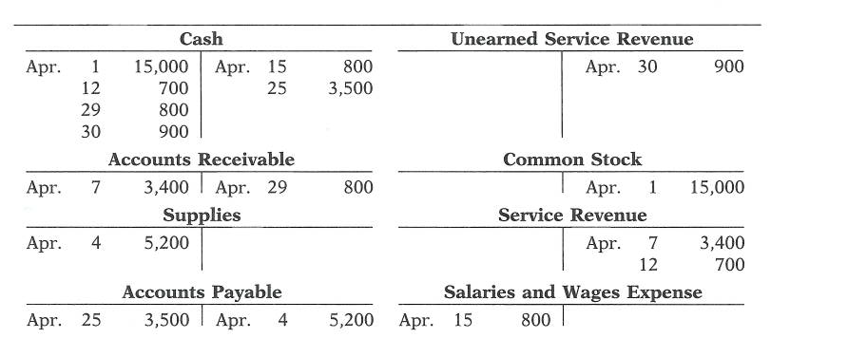
Instructions
Prepare the journal entries (including explanations) that resulted in the amounts posted to the accounts. Present them in the order they occurred.

General Journal
Date |  | Account Titles and Explanation |  | Debit |  | Credit
EXERCISE 3

Selected transactions from the journal of Eberle Inc. during its first month of operations are presented here:

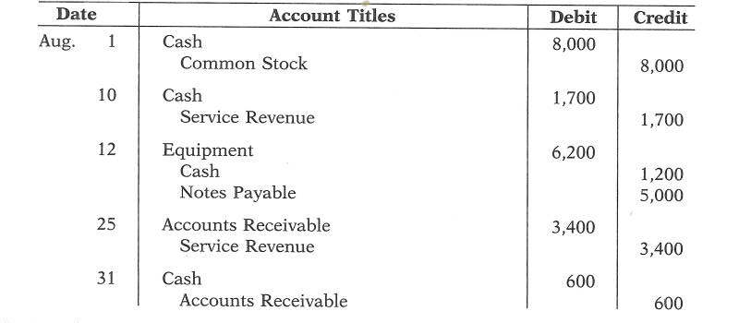

Instructions
Post the transactions to T-accounts

